**Chronic Kidney Disease Prediction**

**by Sweety Ghadge**

**Email Id- ce23.sweety.ghadge@kccemsr.edu.in**

**Mentor Name: Prof.Komal V. Patil**

**Abstract**

Chronic Kidney Disease (CKD) presents a significant global health challenge that can be effectively mitigated through early detection and proactive management. This project introduces a predictive framework for early CKD identification and management by leveraging routine, often-underutilized medical test attributes. The approach is structured around three key scenarios: first, enabling the early detection of CKD through the analysis of routine blood and urine test results, such as creatinine and albumin levels, to facilitate timely intervention. Second, the system employs artificial intelligence to analyze historical patient data and key biomarkers like GFR and serum creatinine to predict disease severity and survival outcomes, thereby supporting personalized treatment planning. Finally, the framework continuously monitors the progression of the disease in diagnosed patients by tracking changes in vital biomarkers over time, providing physicians with real-time alerts for necessary treatment adjustments. This progressive approach aims to transform health management by using predictive analytics to provide a comprehensive, data-driven tool for clinicians, ultimately leading to improved patient outcomes and reduced risk of end-stage renal failure.

**Introduction**

**Problem Statement :**

Chronic Kidney Disease (CKD) is often diagnosed too late because valuable early indicators in routine medical test results are overlooked. This leads to a reactive approach, causing severe disease progression and poor patient outcomes. The problem is to create a proactive, data-driven system that uses predictive analytics to enable early detection, predict disease severity, and monitor progression, empowering clinicians to provide timely and effective treatment.

**Objective :**

• Early Detection: Create a model that uses routine medical tests to detect Chronic Kidney Disease (CKD) early.

• Predictive Analysis: Develop an AI system to predict disease severity and patient survival based on key biomarkers.

• Disease Monitoring: Build a system to continuously track biomarkers and alert physicians to disease progression.

• Clinical Support: Provide doctors with a tool that offers data-driven insights to help them make better treatment decisions.

**Tools and Technologies Used :**

* Languages: Python, HTML, CSS, JavaScript
* Machine Learning Libraries: NumPy, Pandas, Matplotlib, Scikit-learn
* Web Development Tools: Flask (for backend), Bootstrap (for styling)
* Development Tools: Jupyter Notebook, VS Code
* Version Control: Git/GitHub
* Data Source: CSV/Excel datasets

**System Design :**

Architecture

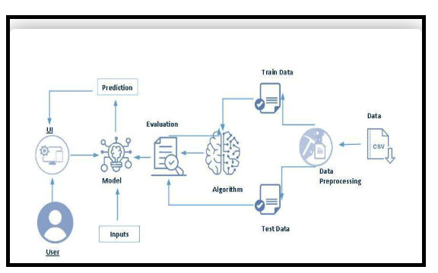

Workflow diagram :

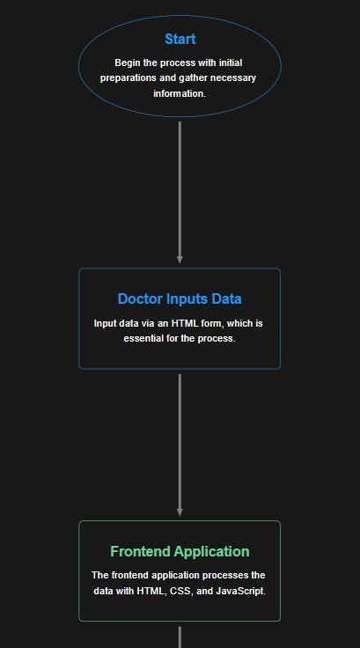

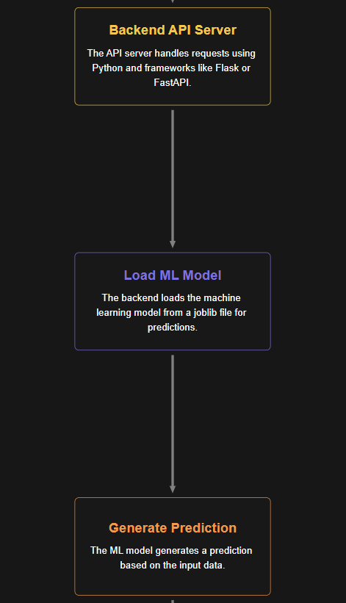

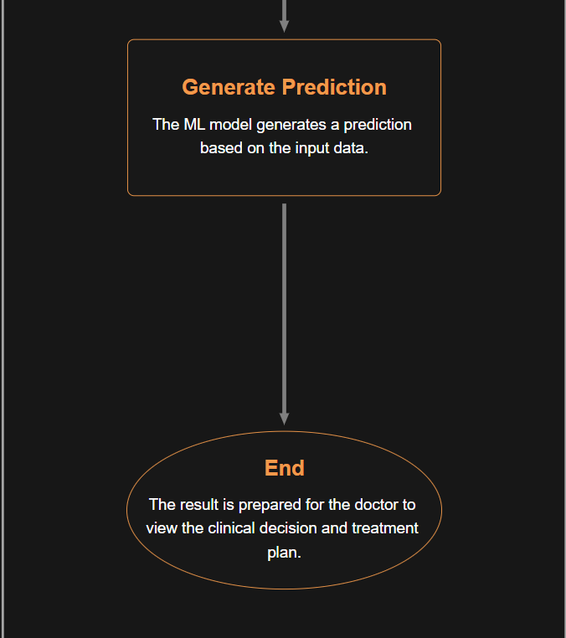

**Implementation :**

**Key Milestones and Project Flow**

* **User Interaction**
  + Users access a user interface (UI) to input relevant test data.
* **Model Analysis**
  + The input data is processed by an integrated predictive model.
* **Prediction Display**
  + Predictions regarding CKD status are presented to the user through the UI.

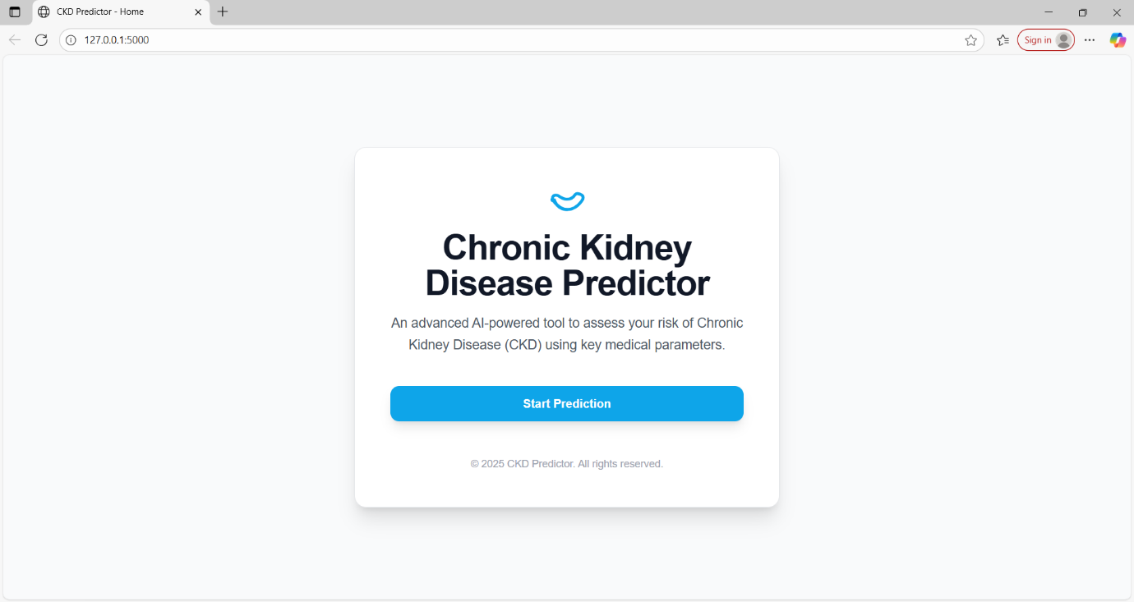

This is the **home page UI** of the Chronic Kidney Disease (CKD) Predictor.  
It features a clean, centered card showing the project title, a short description of its purpose (AI-based CKD risk assessment), and a **“Start Prediction”** button that directs users to input their medical parameters for prediction. The page runs locally on 127.0.0.1:5000 using a Flask backend, with HTML/CSS (possibly Bootstrap) for styling.

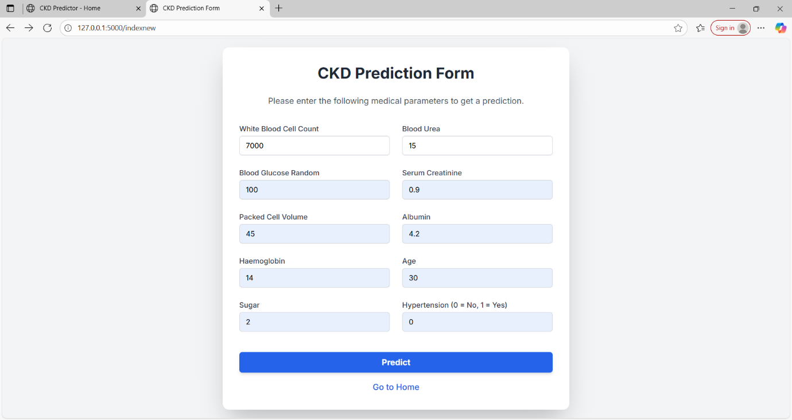

This screenshot shows the **CKD Prediction Form** page of your Chronic Kidney Disease Predictor project.

**Short explanation (with respect to the project):**  
This page collects the required **medical parameters** from the user to predict CKD risk. The form contains input fields for values such as **White Blood Cell Count, Blood Urea, Blood Glucose, Serum Creatinine, Packed Cell Volume, Albumin, Haemoglobin, Age, Sugar level, and Hypertension status**. Once the user enters these values, they can click the **“Predict”** button to send the data to the machine learning model via the Flask backend for risk prediction. A **“Go to Home”** link is also provided for navigation back to the main page.

It’s built using **HTML/CSS (likely Bootstrap)** for layout and styling, and **Flask (Python)** for backend processing.

If you want, I can now combine this with your **home page explanation** so it becomes a neat “UI Description” section for your project report.

**Result :**

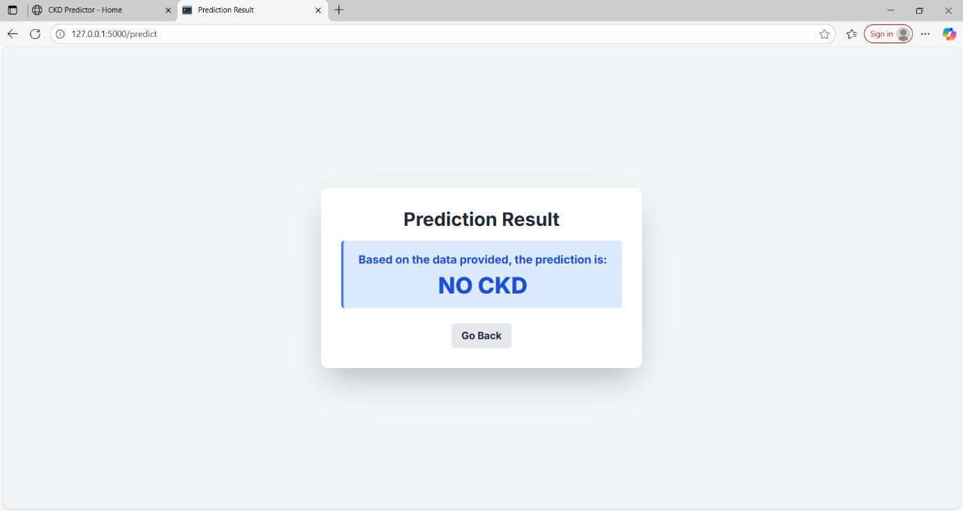

This screenshot shows the Prediction Result page of your Chronic Kidney Disease Predictor project.

Explanation:  
After the user enters medical parameters on the CKD Prediction Form and clicks “Predict”, the data is sent to the backend Flask server, where the trained machine learning model processes it. The model then outputs whether the patient is at risk of CKD.

In this test case, based on the input values provided earlier (e.g., White Blood Cell Count = 7000, Blood Urea = 15, etc.), the model predicts:

Result: NO CKD

* This means the ML model determined that the given parameters do not indicate chronic kidney disease risk.

The page clearly displays this result in a highlighted blue box, along with a “Go Back” button to return to the form for further testing or different input values.

If you want, I can now make a combined step-by-step “UI & Testing Flow” for all three screenshots — it will look neat in your project report. That way, it shows the complete process from home → form → result.

Deployment link :

<http://127.0.0.1:5000/>

<http://127.0.0.1:5000/indexnew>

<http://127.0.0.1:5000/predict>

**Methodology :**

**1. Define Problem / Problem Understanding**

* Deeply analyze the challenges associated with late-stage CKD detection and the implications for patient health.

**2. Specify the Business Problem**

* Clearly define how late detection of CKD results in increased healthcare costs, reduced patient quality of life, and higher mortality rates.

**3. Business Requirements**

* Identify requirements for effective implementation of CKD detection and monitoring system, including data privacy, user interface design, and reporting functionalities.

**4. Literature Survey**

* Conduct a comprehensive review of prior research to identify existing methodologies for CKD detection and the effectiveness of different predictive modeling techniques.

**5. Social or Business Impact**

* Assess the broader implications of early CKD detection and management on public health, health equity, and healthcare systems.

**6. Data Collection & Preparation**

* **Collect the Dataset:** Gather relevant historical patient data from clinics and hospitals.
* **Data Preparation:** Clean and preprocess the data to ensure quality and consistency.

**7. Exploratory Data Analysis (EDA)**

* **Descriptive Statistical Analysis:** Summarize data characteristics and identify key features.
* **Visual Analysis:** Use visualization tools to identify patterns and relationships in the data.

**8. Model Building**

* Train multiple algorithms (e.g., logistic regression, decision trees, random forests, neural networks) to determine the most effective model for predicting CKD.

**9. Testing the Model**

* Validate the model using separate test datasets to ensure reliability.

**10. Performance Testing & Evaluation**

* Utilize various evaluation metrics (accuracy, precision, recall, F1 score, AUC-ROC) to assess model performance.

**11. Model Deployment**

* Save the best-performing model and integrate it with a web framework to facilitate user access and interaction.

**12. Project Demonstration & Documentation**

* **Record Explanation Video:** Create a video that explains the project and showcases the end-to-end solution.
* **Project Documentation:** Provide a detailed step-by-step guide on the development procedure, challenges faced, and solutions implemented.

**Conclusion :**

This project represents a significant step towards the proactive management of Chronic Kidney Disease. Through the application of data analysis and machine learning techniques, we aim to improve early diagnosis, inform treatment decisions, and ultimately enhance patient quality of life. By engaging healthcare providers and patients with actionable insights, we hope to create a sustainable impact on public health concerning CKD.

**References :**

<https://gemini.google.com/app/a51425770efeec69?hl=en-IN>

<https://chatgpt.com/c/689789ff-44ac-832c-9d01-ec34b330e1f2>